Alex Childers

12/06/2018

PA #5: Graphs

Reflection Essay

If I were to rate my own work on this homework assignment, I’d give it a 6.3/10. I’m not happy with my implementation of Task 4A (outputting whether two actors are connected), but I feel like this assignment got easier to understand the more I completed, and I’m proud that I implemented all the tasks fully, including completing Task 1 early and finishing Task 2 to modify the program’s output.

For me, the most challenging aspect of this assignment was Task 4B. I had a difficult time trying to come up with an algorithm to output the path taken from one actor to another. I think that part of the reason I found this task so difficult is because I didn’t implement Task 4A very well. After finishing Task 1 and 3, I implemented Task 4A. I didn’t have a good idea of what the algorithm for accomplishing Task 4A would be, so I referenced class lecture notes and essentially brute-force-coded my way to a solution. I managed to fully complete Task 4A in about an hour, but I didn’t realize until afterwards that I’d implemented a depth-first search, whereas it seemed like I would need to implement a breadth-first search for 4B and 5.

With that realization, I was stuck on what the algorithm for implementing Task 4B would be, so I skipped to Task 5 instead. I actually found Task 5 easier than Task 4B. I think one reason that I found it easier than 4B was because you provided the algorithm as a guide, so all I had to do was convert the algorithm to code. It took me some time to develop and debug the breadth-first search, but I was fully able to do so by referencing lecture notes and drawing out a diagram of the graph on a whiteboard.

Once I finally started task 4B, I was able to draw out a diagram of what I needed to do algorithmically and I felt like I better understood the breadth-first search algorithm. I drew the following BFS tree on a subset of the graph so that I had a longer path I could use to test Tasks 4B and 5. You might find this useful-- zoom in to see the actor and movie IDs; the movie IDs are in blue and actor names/IDs are in black.

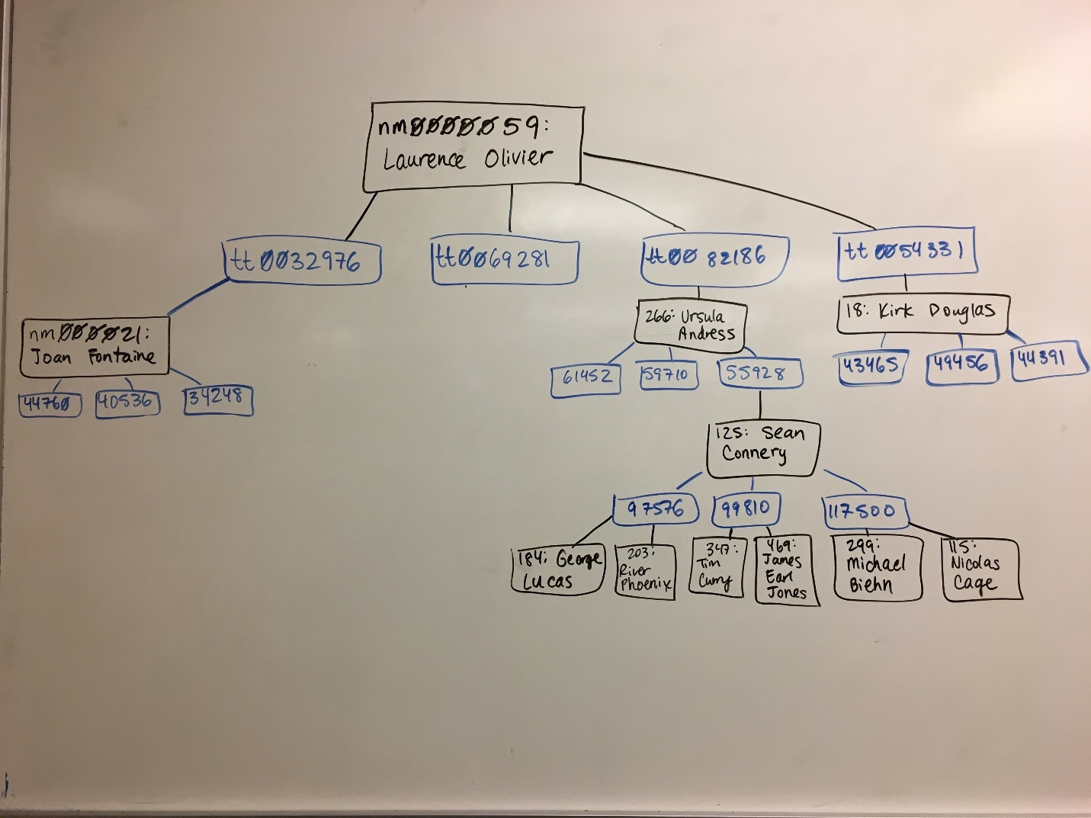

In the end, I was able to work out 4B with a little bit of Google searching on BFS explanations, Wikipedia ([breadth-first search](https://en.wikipedia.org/wiki/Breadth-first_search)), and a lot of whiteboard doodling and diagramming. I’m pretty happy that I kept persisting and working on 4B until I got it right. The Visual Studio debugger was particularly useful for finding my logic errors – I’m not sure how I would have found them otherwise.

For a future student to succeed on the assignment, I would advise them not to do what I did. They should think about what type of search would best suit each task (in my opinion, BFS was clearly better for tasks 4B and 5), the series in which they will implement the task, and the steps taken to complete each task. I think if I had taken the time to more fully process the tasks and subtasks before I started actually coding them, I would have understood Task 4B more quickly than I did.